

Project Name: Online Art Gallery

Branch PG-DAC March-2022

Documentation On

**“Online Art Gallery”**

PG-DAC MARCH 2022

**Guided By: Prathamesh Naik**

Submitted By:

**Group No: 17**

* **Pooja Bolkar 220343020019**
* **Ashwini Mule 220343020053**
* **Omkar Ganjave 220343020057**
* **Prajwal Patil 220343020064**

**Table of Contents**

**1. Introduction 4**

1.1 Document Purpose **4**

1.2 Project Background **4**

1.3 Aim & Objectives **4**

**2. Business Requirements Overview………………...………………………………………5**

**3. Functional Requirements 5**

3.1 Artist Module **5**

3.2 Customer Module **6**

3.3 Admin Module **6**

**4.** **Non-Functional Requirement …..…………………………………………………………6**

**5. Use Case Diagram 7**

5.1 Artist **7**

5.2 Customer **8**

5.3 Admin **9**

**6. Database Design 10**

1. User table **10**

2. Artist table **10**

3. Customer table **10**

4. Product table **11**

5.Category table **11**

6.Orders table…………………………………………………………….………………………………………**11**

7.Cart table…………………………………………………………….…………………………………………..**11**

8.Cart details table **11**

**7. E-R Diagram………………………………………………………………………………………12**

**8. Snapshots 13**

**9. Conclusion 20**

**List of Figures**

**Use Case Diagrams 7**

Fig 1 Artist 8

Fig 2 Customer 9

Fig 3 Admin 10

Fig 4 ER Diagram 12

* **Introduction:**
* **Document Purpose:**

This document communicates the business requirements and scope for developing Online Art Gallery System. The scope of this document is to define the functional and non-functional requirements, business rules and other constraints requirements.

* **Project Background:**

This project intends to include various features related to an art gallery i.e. information about gallery, artists, their paintings, customers (the one who bought the paintings) etc. The main aim is to help art lovers know about different art forms, art work and artists.

People who wish to buy this art work can very easily purchase the art from website. There is a login page for administrator, artists and customer. Artists can login through their account and include details about new paintings made by them. Customers can login through their account and see different paintings available for selling purpose. Administrator can include details about new art works.

* **Aim & Objectives:**

The main objective of this project is to build a website which will help the artist to showcase their art work and sell their paintings online.

This website will provide more options for customer to choose the artwork as per their requirements. Also customer can buy the artworks from the website directly.

* **Business Requirements Overview:**
* Online Art Gallery System is the public web application.
* Online Art Gallery System will be opened to the global, but in the phase 1 only Pune city.
* There are mainly two types of users. One is the Artist and other is Customer.
* Customer can search the artwork of Artist.
* Artist can promote their artwork on one platform to reach several Customers.
* Online Art Gallery System provides the functions which connect the Artist and the Customer efficiently.
* Online Art Gallery System could be maintained by Administrator.
* **Functional Requirements Overview:**

Online Art Gallery System consists of three modules described as below.

* Artist Module
* Customer Module
* Admin Module

3.1 Artist Module

* Artist can register and create his account.
* He is able to see their artwork list.
* Artist can add new artwork.
* Artist can update profile details.
* Artist can delete artwork.

3.2 Customer Module

* Customer can register and create their own account.
* He is able to see Artwork list.
* Customer can update profile details
* Customer can search product.
* Customer can delete cart.
* Customer can place order.

3.3 Admin Module

* Online Art Gallery should provide all function to admin how to handle the System.
* Admin has controls of all the functionalities of customer and Artist module.
* Admin can delete the Customer and Artist.
* Admin can view all register Customer and Artist.
* **Non-Functional Requirement:**
* The website should use professional design, look and feel and colour scheme.
* Users will have no limitations for accessing the application through Internet. The portal being an internet application, it is difficult specify exact number of visitor or users. Hence we will target the system to support between 5 and 10 million users on launch of phase 1.
* Being a public website, the site must follow general usability guidelines for menus, navigation, colours, links and other actions provided on the screens.
* The system should be designed in such a manner that user will be able to complete tasks in minimum number of steps.

**5. Use-Case Diagram**

**5.1 Artist:**

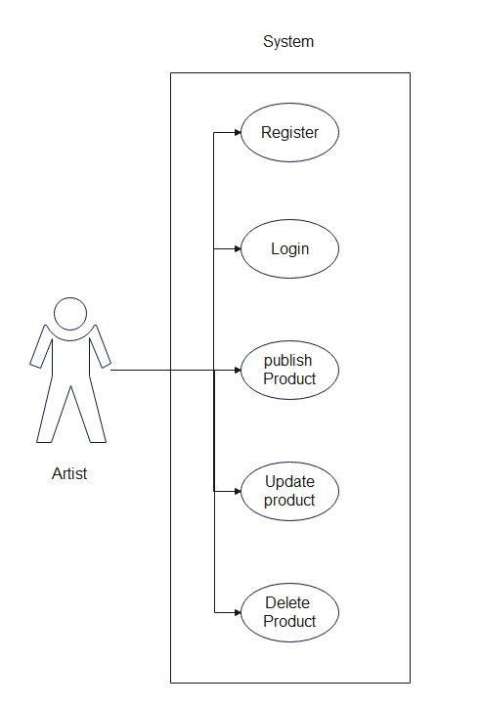

*Fig. Use case diagram for Artist*

**5.2 Customer:**

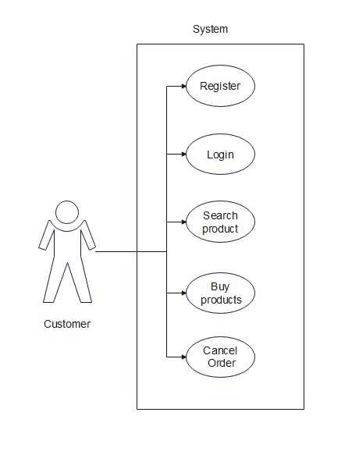

*Fig. Use case diagram for Customer*

**5.3 Admin:**

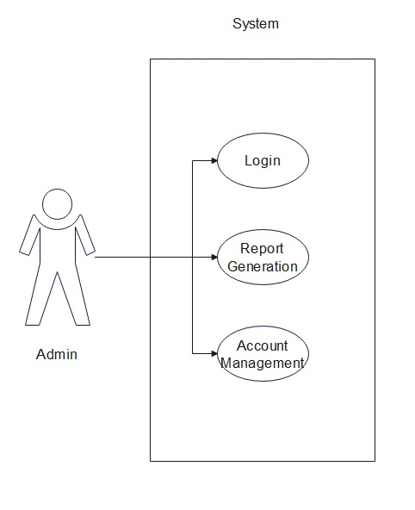

Fig. Use-Case Diagram for Admin

**6. Database Design:**

**1] User table**

|  |  |  |  |  |
| --- | --- | --- | --- | --- |
| **Field** | **Type** | **Null** | **Key** | **Default** |
| login_id | int | NO | PRI | NULL |
| password | varchar(50) | NO |  | NULL |
| role | varchar(50) | NO |  | NULL |
| status | int | NO |  | 1 |
| user_id | varchar(50) | NO |  | NULL |

**2] Artist table**

|  |  |  |  |  |
| --- | --- | --- | --- | --- |
| **Field** | **Type** | **Null** | **Key** | **Default** |
| artist_id | Int | NO | PRI | NULL |
| last_name | varchar(50) | NO |  | NULL |
| address | varchar(50) | NO |  | NULL |
| contact_no | varchar(50) | NO |  | NULL |
| email_id | varchar(50) | NO |  | NULL |
| first_name | varchar(50) | NO |  | NULL |
| rating | double | NO |  | NULL |
| login_id | int | YES | MUL | NULL |

**3] Customer table**

|  |  |  |  |  |
| --- | --- | --- | --- | --- |
| **Field** | **Type** | **Null** | **Key** | **Default** |
| customer_id | Int | NO | PRI | NULL |
| address | Int | NO |  | NULL |
| contact_no | varchar(50) | NO |  | NULL |
| email_id | varchar(50) | NO |  | NULL |
| first_name | varchar(50) | NO |  | NULL |
| last_name | varchar(50) | NO |  | NULL |
| login_id | Int | YES | MUL | NULL |

**4] Product table**

|  |  |  |  |  |
| --- | --- | --- | --- | --- |
| **Field** | **Type** | **Null** | **Key** | **Default** |
| product_id | Int | NO | PRI | NULL |
| artist_id | Int | YES | MUL | NULL |
| category_id | Int | YES | MUL | NULL |
| price | Double | NO |  | NULL |
| product_discription | varchar(50) | NO |  | NULL |
| product_name | varchar(50) | NO |  | NULL |
| status | Int | YES |  | 1 |

**5] Category table**

|  |  |  |  |  |
| --- | --- | --- | --- | --- |
| **Field** | **Type** | **Null** | **Key** | **Default** |
| category_id | Int | NO | PRI | NULL |
| category_name | varchar(50) | NO |  | NULL |

**6] Orders table**

|  |  |  |  |  |
| --- | --- | --- | --- | --- |
| **Field** | **Type** | **Null** | **Key** | **Default** |
| order_id | int | NO | PRI | NULL |
| double | double | YES |  | 0 |
| customer_id | int | YES | MUL | NULL |

7] **Cart table**

|  |  |  |  |  |
| --- | --- | --- | --- | --- |
| **Field** | **Type** | **Null** | **Key** | **Default** |
| cart_id | int | NO | PRI | NULL |
| customer_id | int | YES | MUL | NULL |

8] **Cart details table**

|  |  |  |  |  |
| --- | --- | --- | --- | --- |
| **Field** | **Type** | **Null** | **Key** | **Default** |
| cart_details_id | int | NO | PRI | NULL |
| cart_id | int | YES | MUL | NULL |
| product_id | int | YES | MUL | NULL |

**7. ER-Diagram:**

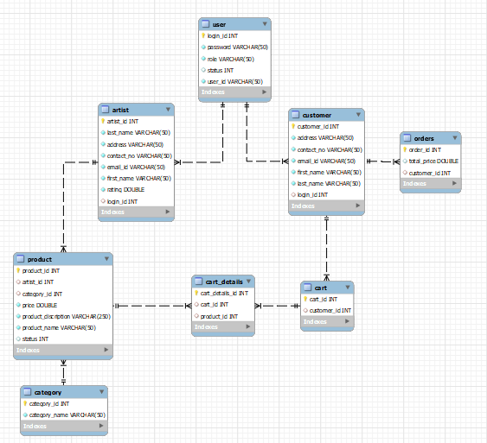

**E-R diagram shows database of Online Art Gallery**

**8. Snapshots:**

**8.1 Home Page:**

Following snapshot shows the Home page for Online Art Gallery System

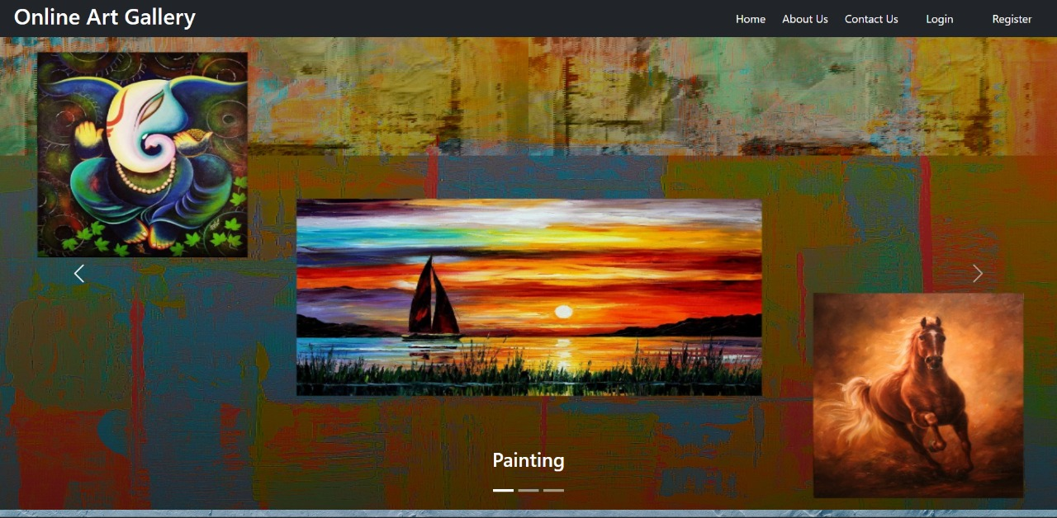

This page contains following controls

* Home
* About
* Contact us
* Login Button
* Logout

**8.2 Login Page**

Following snapshot shows the Login page for Online Art Gallery Management System

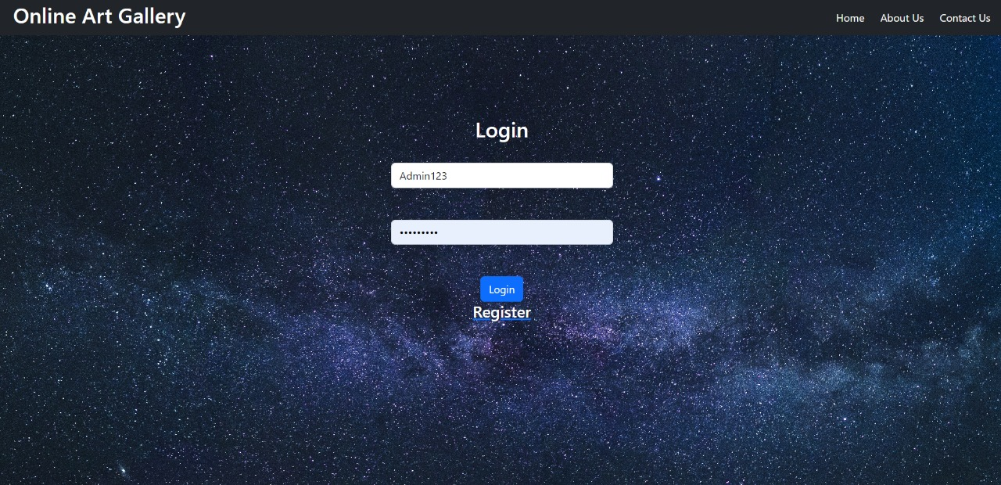

**8.3 Registration Page**

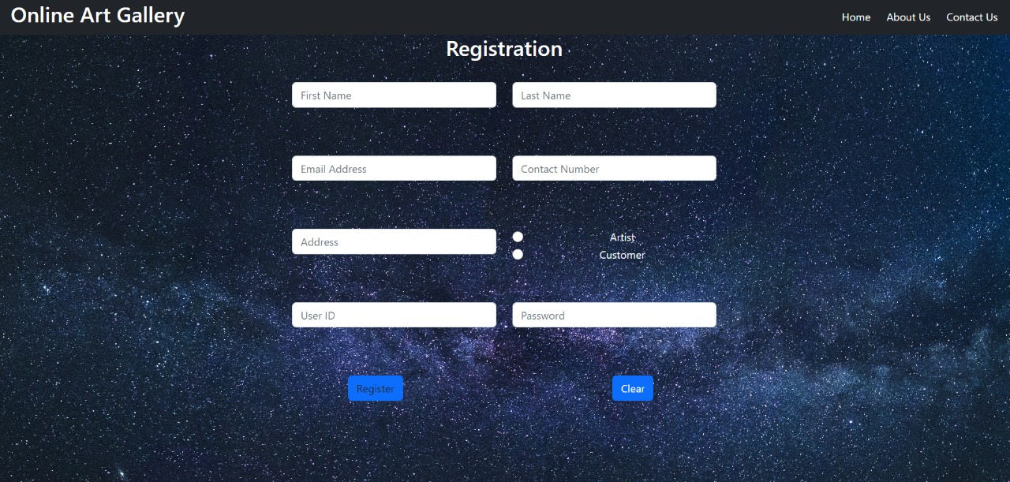

**8.4 Contact us Page**

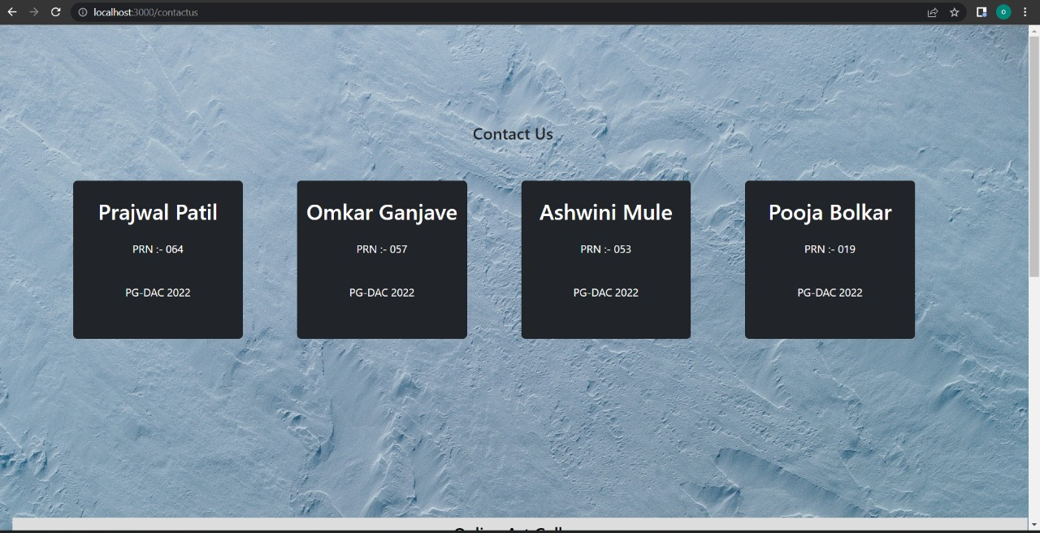

**8.4About us Page**

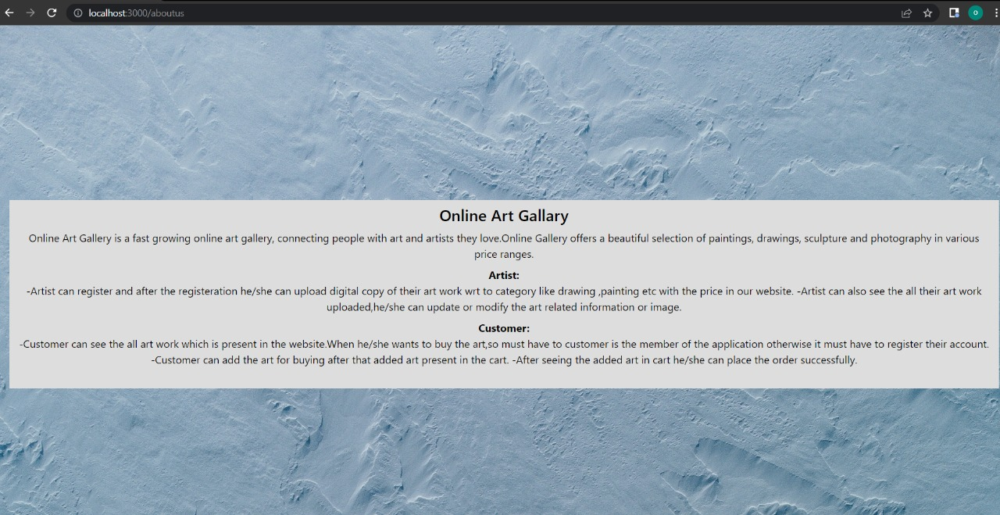

**8.6 Customer Home Page**

**8.6.1 All Artwork List**

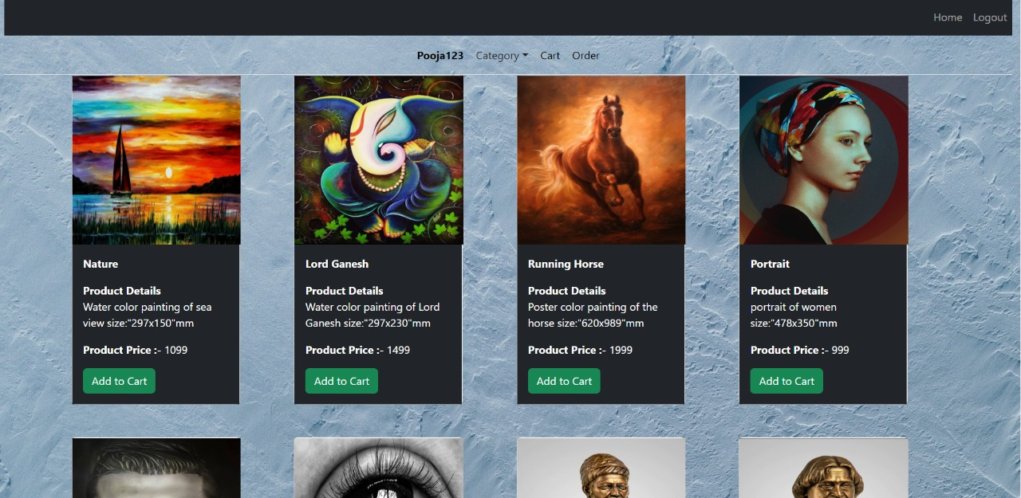

**8.6.2 Customer Search Artwork with Respective Category:-**

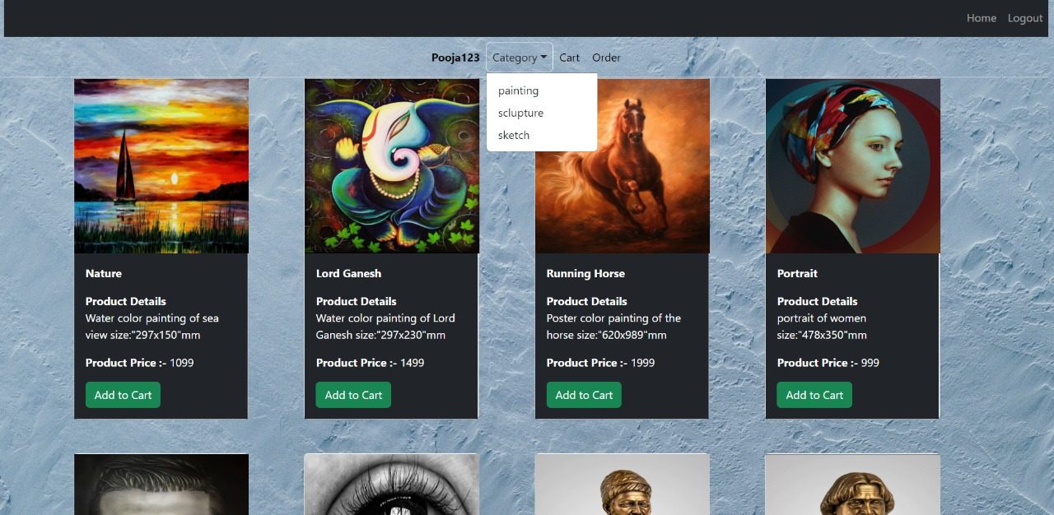

**8.6.3 Customer Add/Remove Product in cart:**

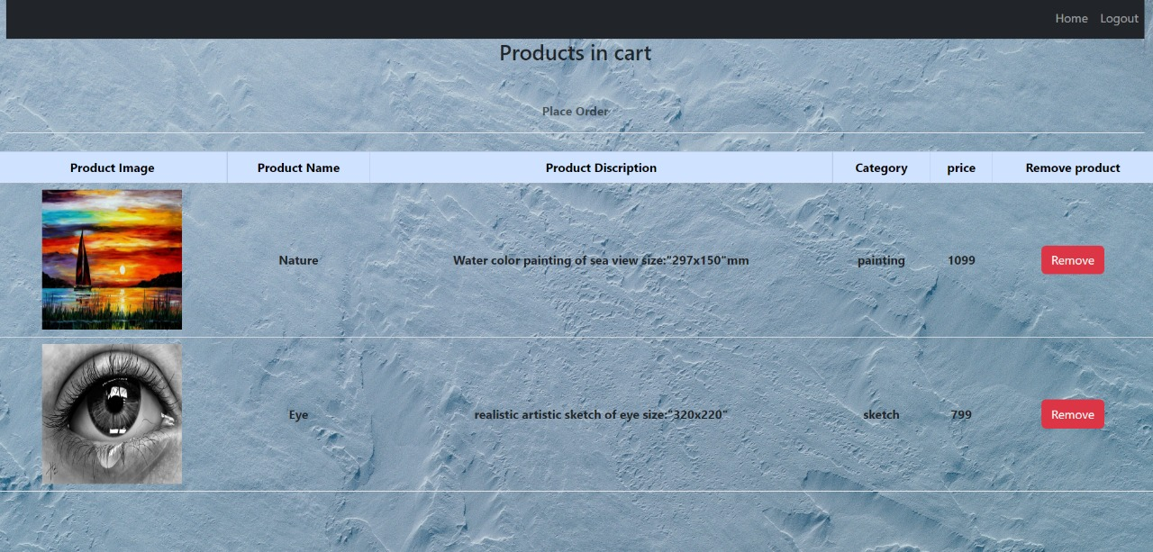

**8.6.4 Customer Place Order:**

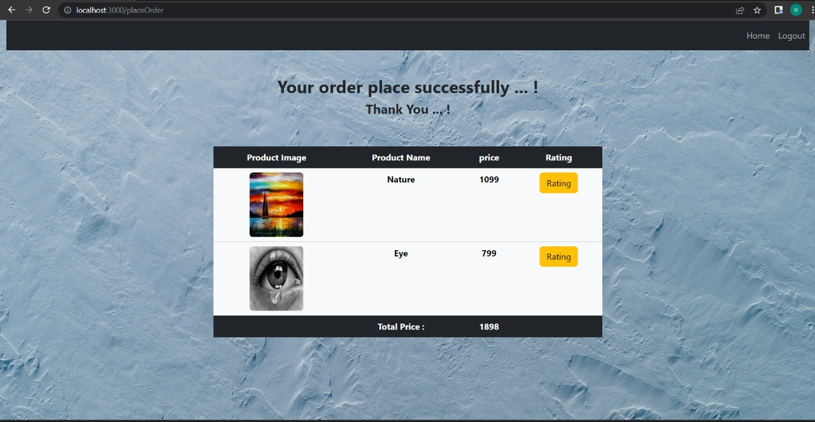

**8.7 Artist Home Page**

**8.7.1 Artist Add Art Work**

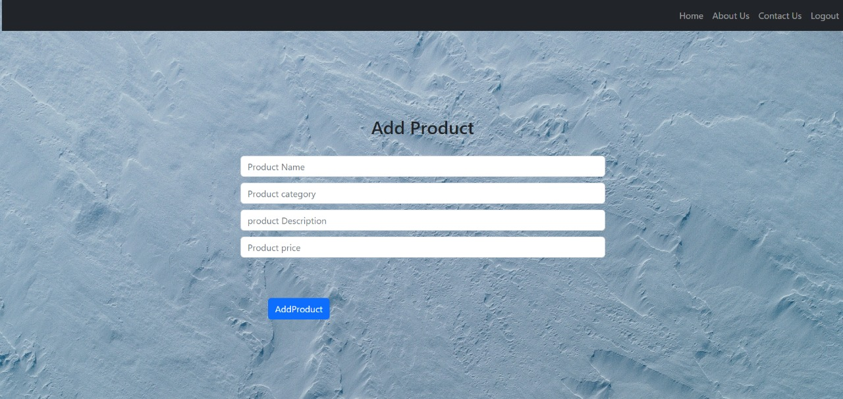

**8.8 Admin Home Page**

**8.8.1 Add New Category**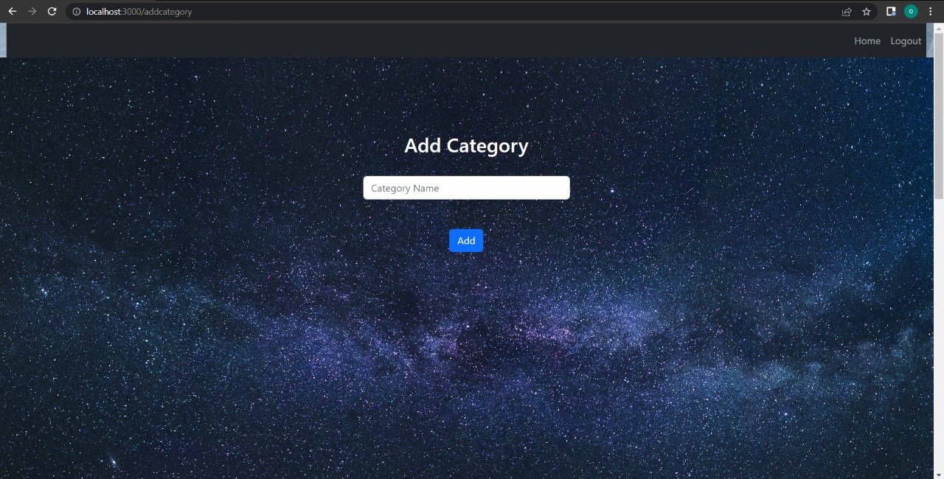

**8.8.2 Account Management**

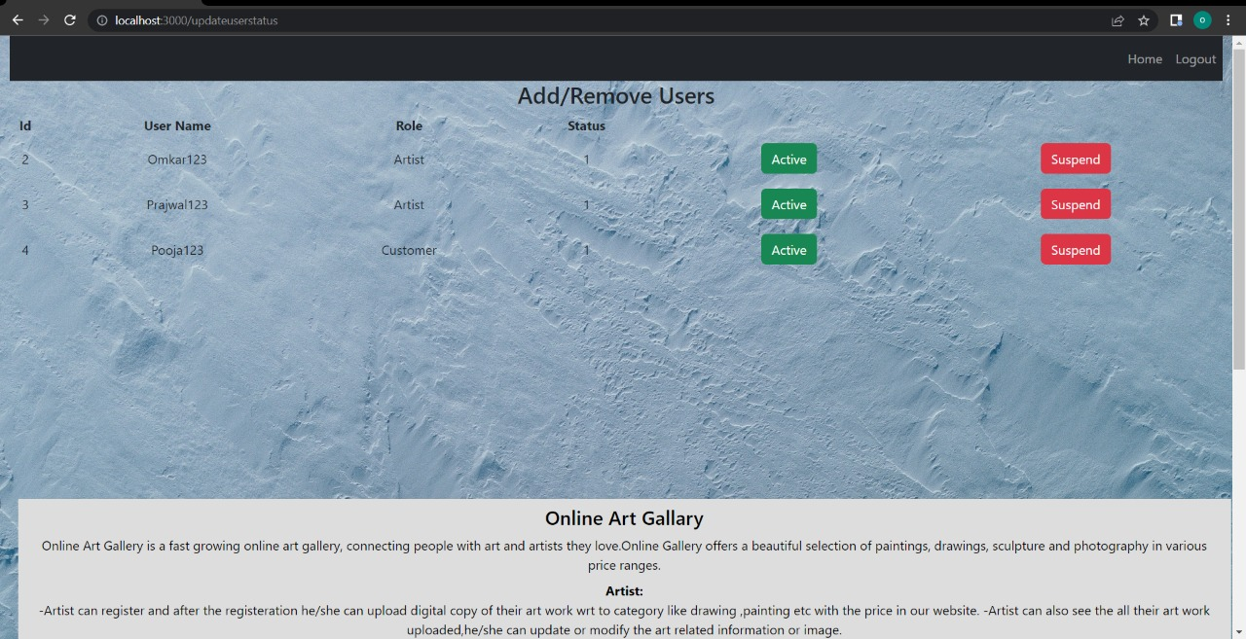

**9. CONCLUSION AND FUTURE SCOPE**

Online Art Gallery System provides artwork platform to get connected with different Artist and Customer efficiently.

Our System provides a very user-friendly platform where Artist can promote their artwork and Customer can easily find their artwork. Customer can register on website and find list of all the Artwork offered by Artist. Customer can see artwork and also Customer can give feedback to Artist.